Perpendicular Lines
# Source: AI Source: Provided by: [Data Path: Persons Table -> ID Column: 1, Name_En Column: Motasem Essam] -> From: [ChatGPT] on [7/25/2026]
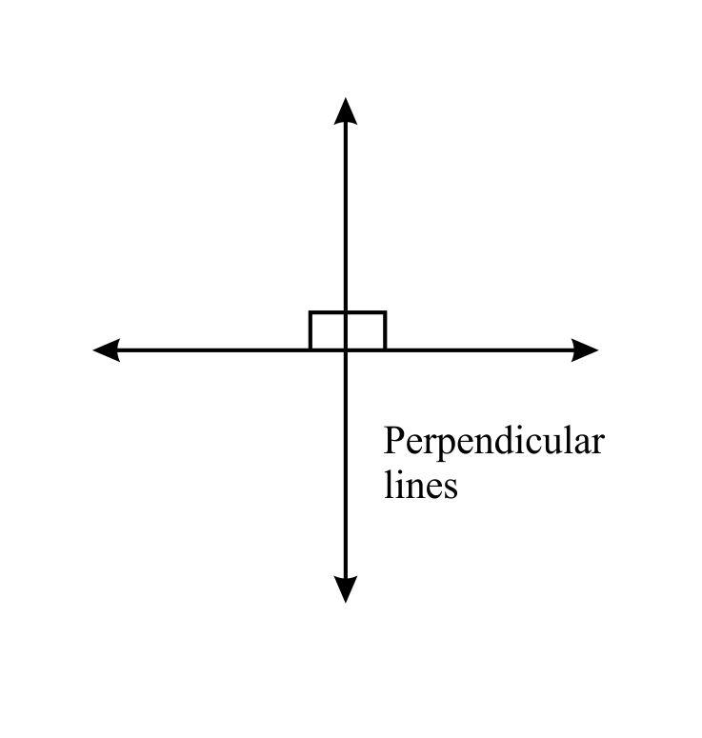
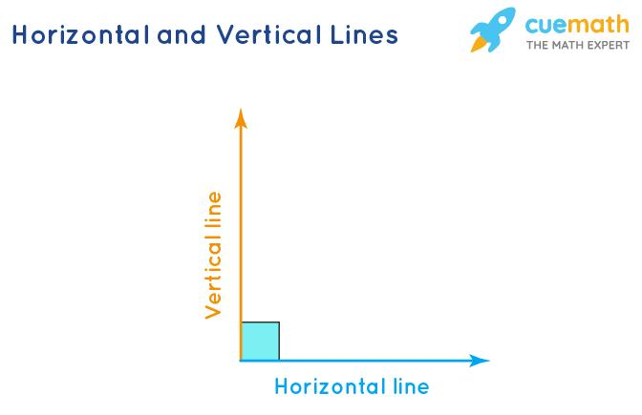
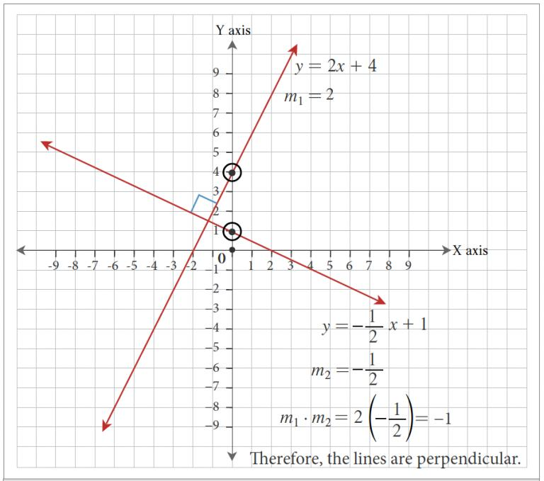
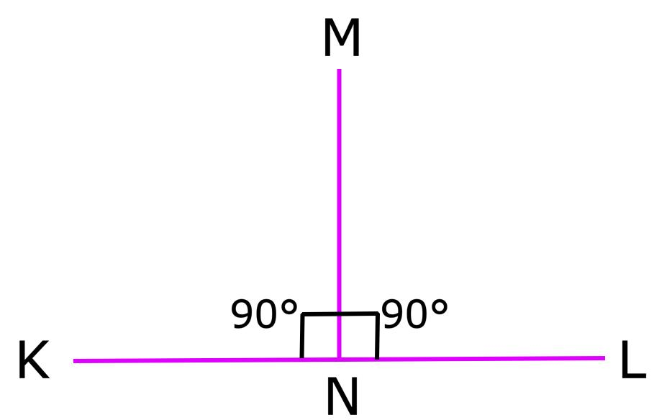
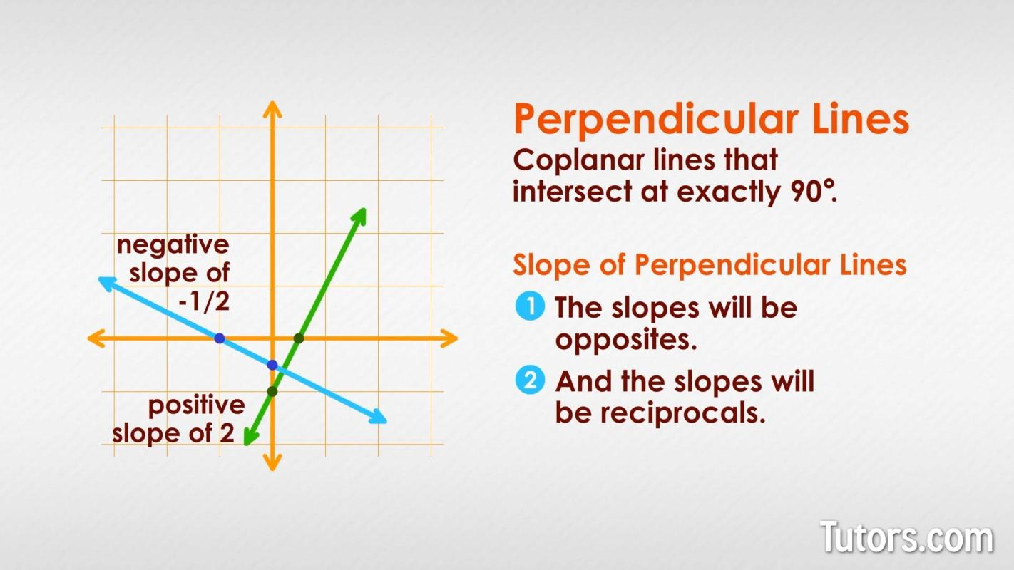
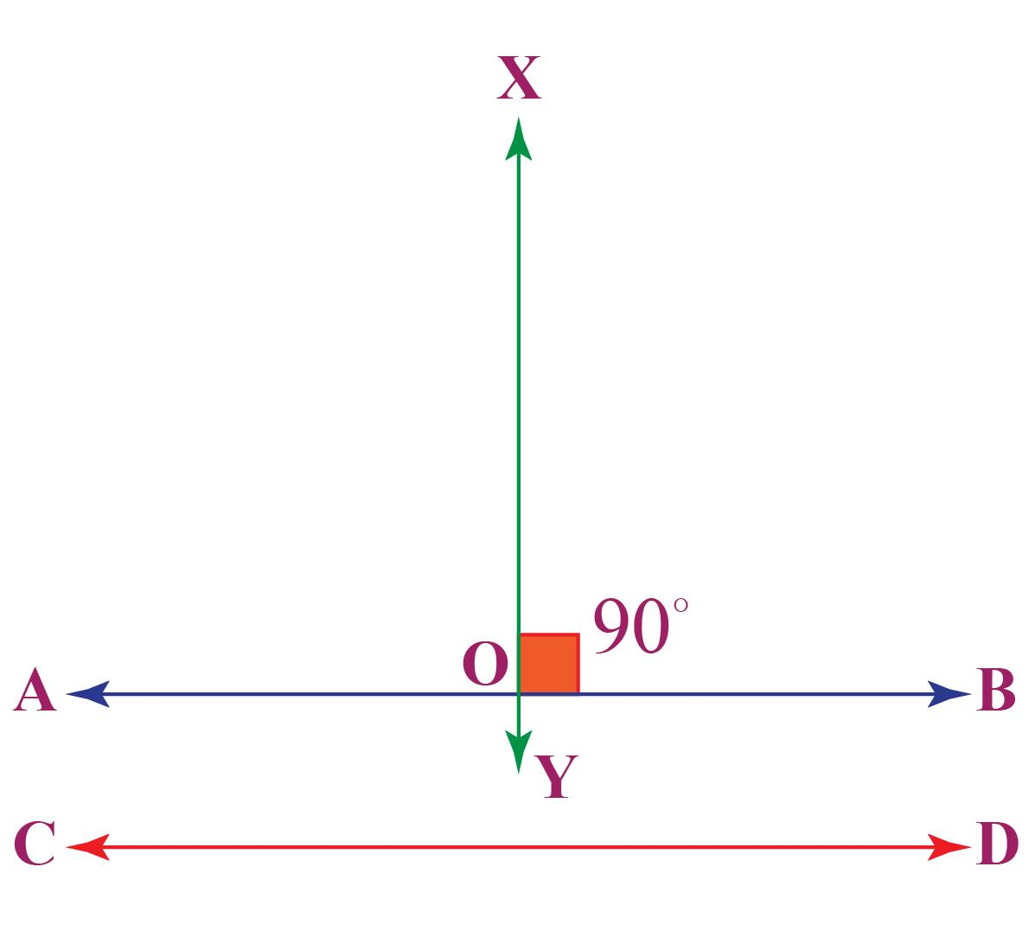

Definition
# Source: AI Source: Provided by: [Data Path: Persons Table -> ID Column: 1, Name_En Column: Motasem Essam] -> From: [ChatGPT] on [7/25/2026]
Perpendicular Lines are two lines that intersect to form a right angle (90°). At their point of intersection, each of the four angles formed measures exactly 90 degrees.
Perpendicular lines are one of the fundamental relationships between lines in plane geometry.

Characteristics
# Source: AI Source: Provided by: [Data Path: Persons Table -> ID Column: 1, Name_En Column: Motasem Essam] -> From: [ChatGPT] on [7/25/2026]
Perpendicular lines:
- Intersect at exactly one point.
- Form four right angles.
- Meet at an angle of 90°.
- May be horizontal and vertical, or oblique.
- Have slopes that are negative reciprocals of each other (for non-vertical lines).

Illustration
# Source: AI Source: Provided by: [Data Path: Persons Table -> ID Column: 1, Name_En Column: Motasem Essam] -> From: [ChatGPT] on [7/25/2026]
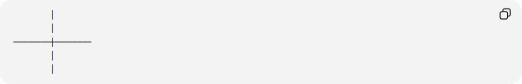
│
│
────────┼────────
│
│
The small square indicates a 90° angle.

Mathematical Representation
# Source: AI Source: Provided by: [Data Path: Persons Table -> ID Column: 1, Name_En Column: Motasem Essam] -> From: [ChatGPT] on [7/25/2026]
Perpendicularity is represented by the symbol:
$$⊥$$
Example:
$$l_{1}⊥l_{2}$$

Coordinate Geometry
# Source: AI Source: Provided by: [Data Path: Persons Table -> ID Column: 1, Name_En Column: Motasem Essam] -> From: [ChatGPT] on [7/25/2026]
Slope Relationship
If two non-vertical lines have slopes:
$$m_{1}$$
and
$$m_{2}$$
they are perpendicular when:
$$m_{1}m_{2}=-1$$
or equivalently,
$$m_{2}=-\frac{1}{m_{1}}$$

Example
Line 1:
$$y=2x+1$$
Slope:
$$m_{1}=2$$
A perpendicular line has slope:
$$m_{2}=-\frac{1}{2}$$
Example:
$$y=-\frac{1}{2}x+4$$

Special Case
# Source: AI Source: Provided by: [Data Path: Persons Table -> ID Column: 1, Name_En Column: Motasem Essam] -> From: [ChatGPT] on [7/25/2026]
A horizontal line and a vertical line are always perpendicular.
Example:
$$y=3$$
and
$$x=5$$

Properties
# Source: AI Source: Provided by: [Data Path: Persons Table -> ID Column: 1, Name_En Column: Motasem Essam] -> From: [ChatGPT] on [7/25/2026]
Perpendicular lines:
- Intersect at exactly one point.
- Form four equal angles of:
$${90}^{∘}$$
- Divide the plane into four right angles.
- Have negative reciprocal slopes (except horizontal and vertical lines).

Examples
# Source: AI Source: Provided by: [Data Path: Persons Table -> ID Column: 1, Name_En Column: Motasem Essam] -> From: [ChatGPT] on [7/25/2026]
Examples of perpendicular lines include:
- The x-axis and y-axis.
- Adjacent edges of a rectangle.
- The corner of a book.
- A wall meeting the floor.
- A building corner.

Applications
# Source: AI Source: Provided by: [Data Path: Persons Table -> ID Column: 1, Name_En Column: Motasem Essam] -> From: [ChatGPT] on [7/25/2026]
Perpendicular lines are used in:
- Plane Geometry
- Coordinate Geometry
- Engineering
- Architecture
- Construction
- Surveying
- CAD (Computer-Aided Design)
- Computer Graphics
- Robotics
- Technical Drawing

Advantages
# Source: AI Source: Provided by: [Data Path: Persons Table -> ID Column: 1, Name_En Column: Motasem Essam] -> From: [ChatGPT] on [7/25/2026]
Studying perpendicular lines helps to:
- Construct right angles.
- Analyze geometric relationships.
- Design buildings and structures.
- Create engineering drawings.
- Solve coordinate geometry problems.

Limitations
# Source: AI Source: Provided by: [Data Path: Persons Table -> ID Column: 1, Name_En Column: Motasem Essam] -> From: [ChatGPT] on [7/25/2026]
Perpendicular lines:
- Must intersect.
- Exist only when the angle between them is exactly 90°.
- Cannot be parallel.

Comparison with Other Types of Lines
# Source: AI Source: Provided by: [Data Path: Persons Table -> ID Column: 1, Name_En Column: Motasem Essam] -> From: [ChatGPT] on [7/25/2026]
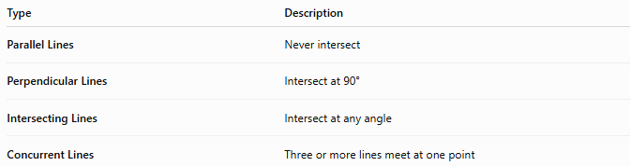
Type | Description
Parallel Lines | Never intersect
Perpendicular Lines | Intersect at 90°
Intersecting Lines | Intersect at any angle
Concurrent Lines | Three or more lines meet at one point

Key Points
# Source: AI Source: Provided by: [Data Path: Persons Table -> ID Column: 1, Name_En Column: Motasem Essam] -> From: [ChatGPT] on [7/25/2026]
- Perpendicular Lines intersect at:
$${90}^{∘}$$
- They are represented by:
$$⊥$$
- For non-vertical lines:
$$m_{1}m_{2}=-1$$
- Horizontal and vertical lines are always perpendicular.
- Perpendicular lines are fundamental in geometry, engineering, architecture, surveying, CAD, and technical drawing.

Conclusion
# Source: AI Source: Provided by: [Data Path: Persons Table -> ID Column: 1, Name_En Column: Motasem Essam] -> From: [ChatGPT] on [7/25/2026]
Perpendicular Lines are lines that intersect to form right angles of exactly 90°, making them one of the most important geometric relationships. In coordinate geometry, non-vertical perpendicular lines have slopes that are negative reciprocals of one another, while horizontal and vertical lines are always perpendicular. Perpendicular lines are essential in plane geometry, coordinate geometry, engineering, architecture, construction, surveying, CAD, robotics, computer graphics, and technical drawing, where precise right-angle relationships are fundamental for accurate design, measurement, and structural integrity.

